// Assignment no-5(1)

// Name- Prerana Rajesh Gajare Class-SEIT RollNo-SI41

/\*PROBLEM STATEMENT:-

5. Write an Embedded C menu driven program for :

i) Multiply 8 bit number by 8 bit number

\*/

//Source Code:-

#include <xc.h>

#include <stdlib.h>

#include <pic18f4550.h>

void main (void)

{

int a,b,i,multi;

a=0x04;

b=0x03;

multi=0x00;

for(i=0;i<b;i++)

{

multi=multi+a;

}

TRISD=0;

PORTD=multi;

}

\*\*\*\*\*\*\*\*\*\*\*\*\*\*\*\*\*\*\*\*\*\*\*\*\*\*\*\*\*\*\*\*\*\*\*\*OUTPUT\*\*\*\*\*\*\*\*\*\*\*\*\*\*\*\*\*\*\*\*\*\*\*\*\*\*\*\*\*\*\*\*\*\*\*\*\*\*\*

1. I/O VIE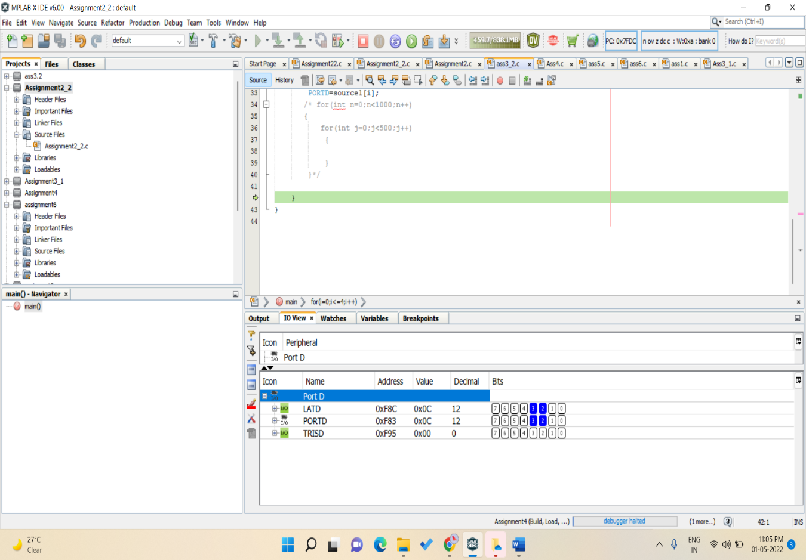W
2. PICSIMLAB OUTPUT

